Topic: Anglo-Saxons and Scots | Year: 4 |  | Spring Term – History – Puffins Class
 |  |  |  | Key Knowledge  - The Anglo-Saxons were  - They came to Britain in  - The Anglo-Saxon’s ruled Britain by  - Alfred the Great and King Offa  - Anglo-Saxon art and culture was  - The Anglo-Saxon
  What should I already know?
  - The Stone Age was when early humans used tools from stone. This lasted until the Bronze Age.
  - The Bronze Age began when settlers arrived from Europe to Britain. These settlers brought with them ways of making tools from metal (bronze).
  - The Iron Age lasted from 800 BC till the Roman invasion (AD 43) - this was when people used tools made from iron.
  - In AD 43, the Romans under the order of Emperor Claudius, first invaded
  Britain and Roman rule lasted until AD 410.
  Stone Age
  Palaeolithic Britain: early
  humans first use tools
  from stone
  approx. 800,000BC
  -
  Mesolithic Britain: end
  of Ice Age to start of
  farming
  approx. 10,5000 BC
  Neolithic Britain:
  start of farming
  approx. 4,000 BC
  Bronze Age: settlers arrived
  from Europe and brought
  ways to make tools with
  metal approx. 2,000 BC
  Iron Age: people made
  tools from iron
  Romans first
  invade Britain
  Diagrams
  Anglo-Saxon migration
  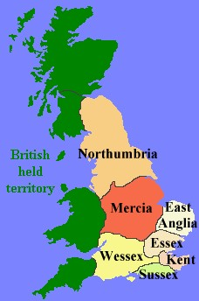
  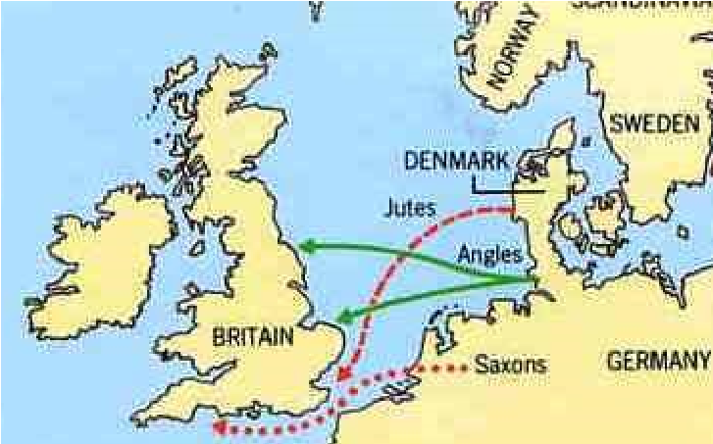
  Seven Kingdoms of AngloSaxon
  Britain
   | Vocabulary
  Angles | people from Germany who invaded Britain around AD 410
  Anglo-Saxon | the name given to the people who travelled from Germany and South Denmark and settled in Britain around AD 410
  archaeologist | someone who studies the past by exploring old remains
  artefact | an object from the past that shows evidence of what life was like
  century | a period of 100 years
  Christianity | the region based on the teachings of Jesus Christ
  invasion | to try and take over a place by force
  Jutes | people from the Jutland peninsula (Germany and Southern Denmark) who invaded Britain around AD 410
  migration | movement from one place to another in order to settle there
  monk | a member of a male religious community
  pagan | a person who follows a religion that is not a major religion, including Christianity, Islam, Judaism, Buddhism, Hinduism, and Sikhism
  Picts | ancient tribes who lived in northern Scotland
  Saxons | people from northern and central Germany who invaded Britain around AD 410
  Scots | people from Ireland who eventually settled in Scotland
  settler/ settlement | people who migrate to a new place. When people start a community, this is a settlement
  source | where something comes from
 | People
Bede | A monk who wrote about life in Anglo-Saxon Britain.
Gildas | A monk who wrote about the leaders of Britain offering land and food in exchange for protection against the Picts and Scots.
Hengist and Horsa | The Jute leaders who were invited to Britain by Vortigen to help defend them from the Picts and Scots in exchange for land.
King Alfred the Great | The King of Wessex who eventually became the first king of England.
King Ethelbert | The King of Kent who converted to Christianity.
St Augustine | A monk who helped spread the word about Christianity.
Vortigen | A king in Britain who offered Hengist and Horsa land and food in exchange for protection.

Historical Skills and Enquiry
- Explain how the Roman withdrawal contributed to Anglo-Saxon settlement.
- Describe what Anglo-Saxon life was like for all groups of people.
- Ask questions and find out the answers about the Anglo-Saxons and Scots.
- Use more than source to find out what Anglo-Saxon life was like. Compare the accuracy of these sources.
- Describe different accounts of the Anglo-Saxon settlement from different perspectives, explaining some of the reasons why the accounts may differ.
- Suggest reasons why the Anglo-Saxons settled in Britain.
- Explain how Britain changed with the Anglo-Saxon settlement.
- Place events on a timeline using dates.
- Compare Anglo-Saxon Britain with Roman life using a Venn diagram.
- Explain what religious beliefs were before the spread of Christianity and how the spread of Christianity impacted Britain.
- Research Anglo-Saxon Sudbury - describe how Sudbury was founded.
- Present what you know about the Anglo-Saxons and Scots using a variety of skills (e.g. Geography English, Maths, Computing)

Timeline | AD 396 - 398: Picts, Scots AD 450: The Angloand Saxons constantly raid Saxons began to settle Roman Britain. alongside the Britons.  AD 410: Romans leave Britain to defend Rome which was under attack. Angles, Saxons and Jutes make their way from Germany and South Denmark. | AD 597: St Augustine helps missionaries AD 789: The spread the word about Christianity. Vikings begin  King Ethelbert converts to Christianity. to raid Britain.  AD 500: By AD 500, AD 731: Bede completes the seven kingdoms the Ecclesiastical History of had been created. English Peoples.

  Question 1: Where can we find evidence of Anglo-Saxon life? | Start of unit: | End of unit:
  artefacts
  archaeological sites
  writing by Gildas and Bede
  all of the above
  Question 5: Place these in order of chronology using the numbers 1-4. | Start of unit: | End of unit:
  Bronze Age
  Anglo-Saxons settlement
  Iron Age
  Stone Age
  Question 8: Whose  writings tell us about life during Anglo-Saxon Britain? Tick two. | Start of unit: | End of unit:
  Romans
  King Alfred
  Bede
  Gildas
Question 2: The AngloSaxons originated from which areas? Tick two. | Start of unit: | End of unit: |  | Question 6: Who is said to have invited the AngloSaxons to Britain? | Start of unit: | End of unit:
England |  |  |  | King Ethelbert
Scotland |  |  |  | King Alfred the Great
Germany |  |  |  | St Augustine
Southern Denmark |  |  |  | Vortigen

Question 9: Travelling from one place to another, with the view of settling there, is called…. | Start of unit: | End of unit:
moving
migrating
sailing
converting

  Question 3: Which year did the Romans leave Britain? | Start of unit: | End of unit:
  3000 BC
  0
  AD 410
  AD 450
  Question 7: What year did King Elthelbert convert to Christianity? | Start of unit: | End of unit:
  AD 410
  AD 500
  AD 597
  AD 700
  Question 10: Invasion means... | Start of unit: | End of unit:
Question 4: How many kingdoms were there in Anglo-Saxon Britain? | Start of unit: | End of unit:
4
5
6
7

